Connecting to Multiple Data Sources

Part I:-

<https://public.tableau.com/profile/sumedh.pandurang.joglekar#!/vizhome/FundamentalsofVisualizationwithTableau_Week3_Part1/Part1>

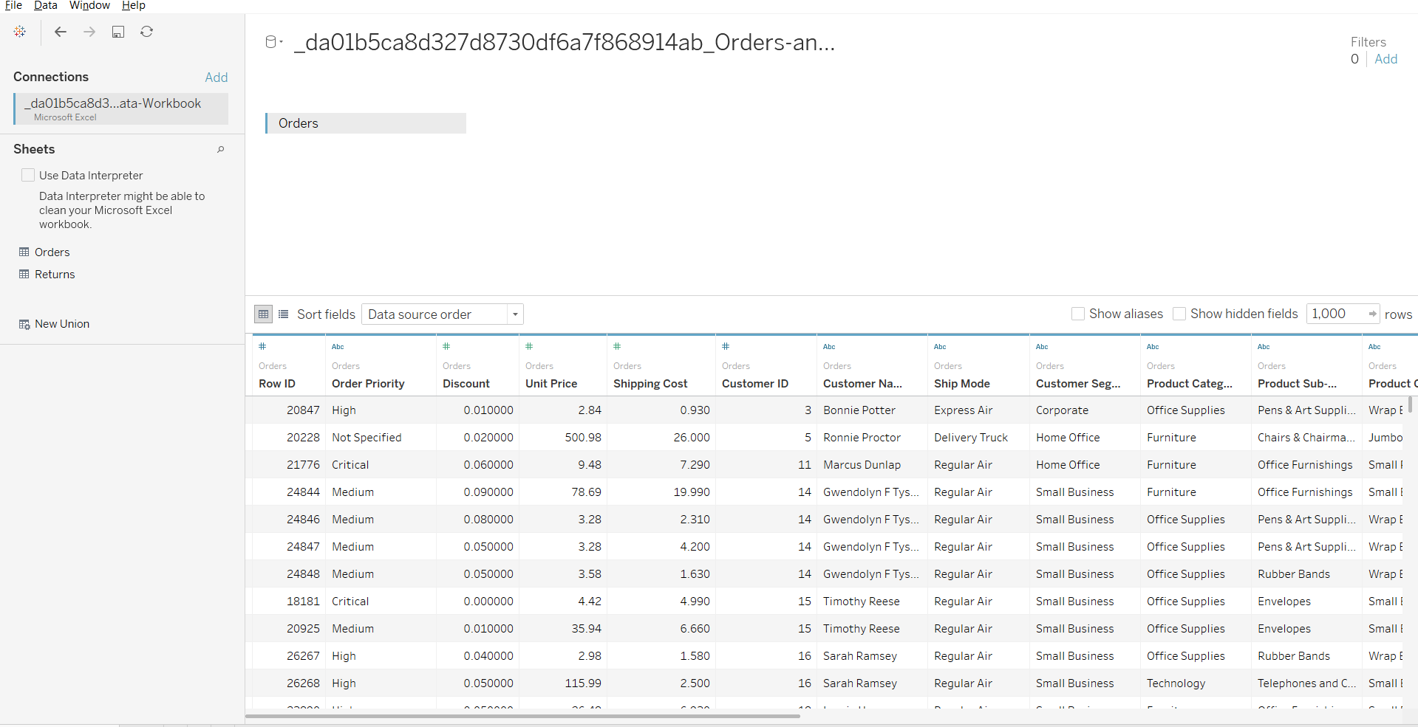

Part II:

<https://public.tableau.com/profile/sumedh.pandurang.joglekar#!/vizhome/FundamentalsofVisualizationwithTableau_Week3_Part2_15619550181110/Part2>

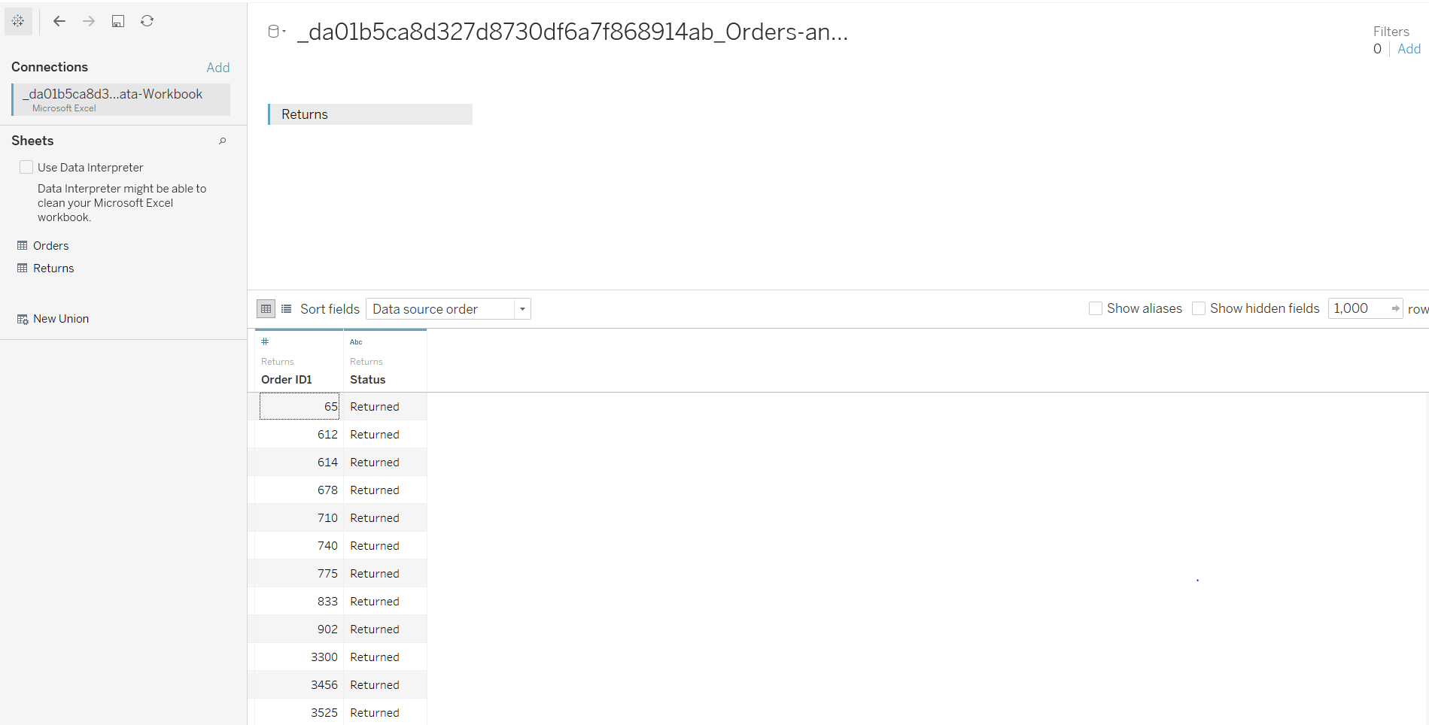

Part III:-

<https://public.tableau.com/profile/sumedh.pandurang.joglekar#!/vizhome/FundamentalsofVisualizationwithTableau_Week3_Part3_15619552128330/Part3>

